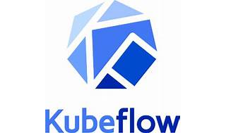

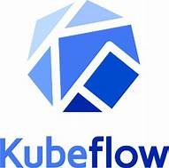

Explore

**Kubeflow** is the **machine learning toolkit for Kubernetes**, simplifying the deployment of ML workflows on diverse infrastructures. [It translates data science steps into Kubernetes jobs, providing a cloud-native interface for ML libraries, frameworks, pipelines, and notebooks1](https://www.kubeflow.org/docs/started/introduction/)[2](https://ubuntu.com/ai/what-is-kubeflow)[3](https://opensource.com/article/18/12/introduction-kubeflow).

Here are **five free resources** to learn more about Kubeflow:

1. [**Kubeflow Documentation**](https://www.kubeflow.org/docs/started/introduction/): Explore the architecture overview and learn how to manage your ML workflow using Kubeflow.
2. [**Udemy Course: Introduction to Kubeflow Fundamentals**](https://www.udemy.com/course/introduction-to-kubeflow-fundamentals/): Dive into components, tools, and installation methods for Kubeflow on AWS, GCP, and locally[4](https://www.udemy.com/course/introduction-to-kubeflow-fundamentals/).
3. [**Udemy Course: Kubeflow Bootcamp**](https://www.udemy.com/course/kubeflow-bootcamp/): Supercharge your data science skills and revolutionize ML workflows with Kubeflow on Google Cloud[5](https://www.udemy.com/course/kubeflow-bootcamp/).
4. [**Kubeflow Official Website**](https://www.kubeflow.org/): Explore the unified interface for model training on Kubernetes, supporting popular frameworks like TensorFlow, PyTorch, and more[6](https://www.kubeflow.org/).
5. [**Kubeflow Pipelines SDK**](https://www.kubeflow.org/docs/started/): Learn how to manipulate Kubernetes resources as part of a pipeline and experiment with the Kubeflow Pipelines API[7](https://www.kubeflow.org/docs/started/).

Happy learning! 🚀📚